Laura Stewart, Nick Peluso, Kurt Gallo, Brian Snyder  
IT 360-41  
Assignment 2  
10/15-11/3/18

# Part I: Wireless Analyzer

For this part we chose the Acrylic Wi-Fi Home analyzer. 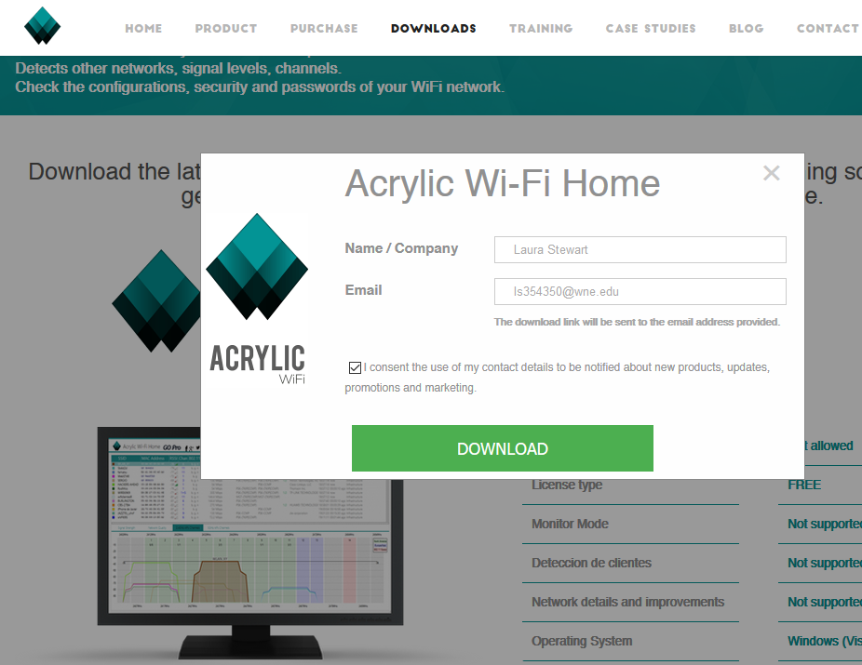 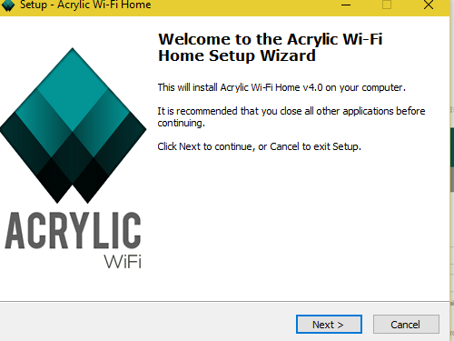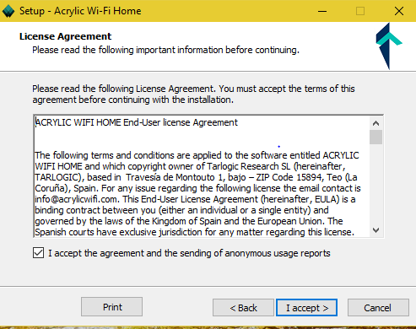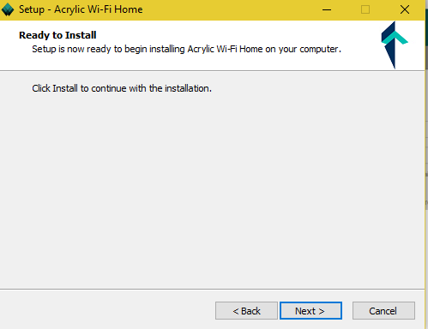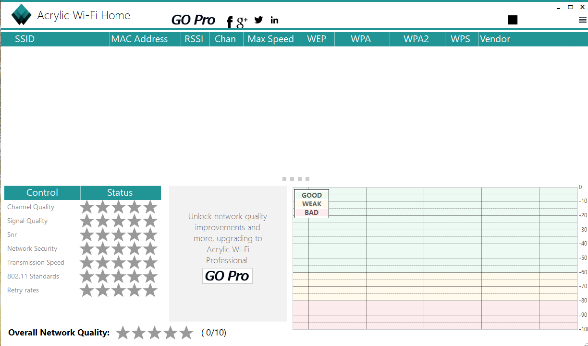

## Campus: H201 classroom

I chose the class in H201, which, since I was one of the few left in class, activity was low. This is a screenshot of details captured after a short period of time: 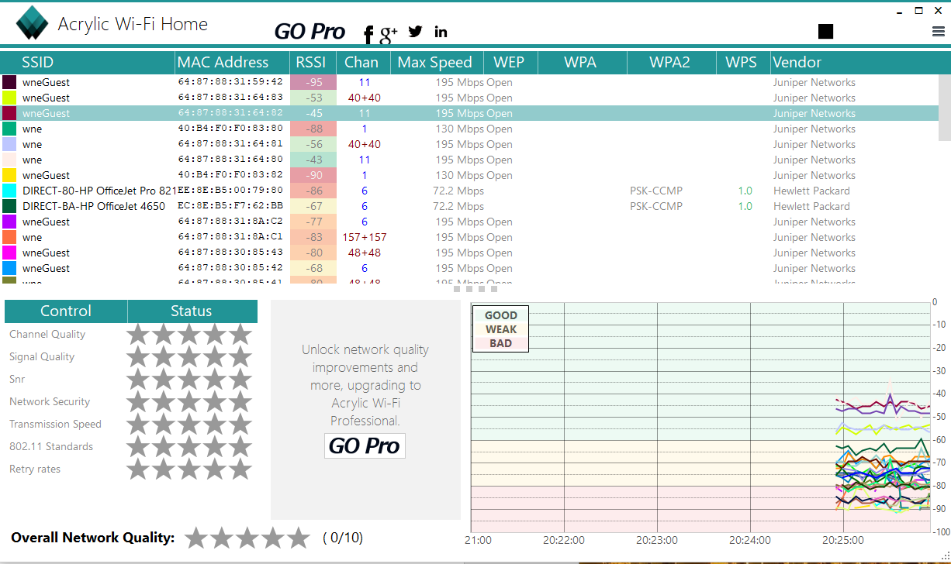

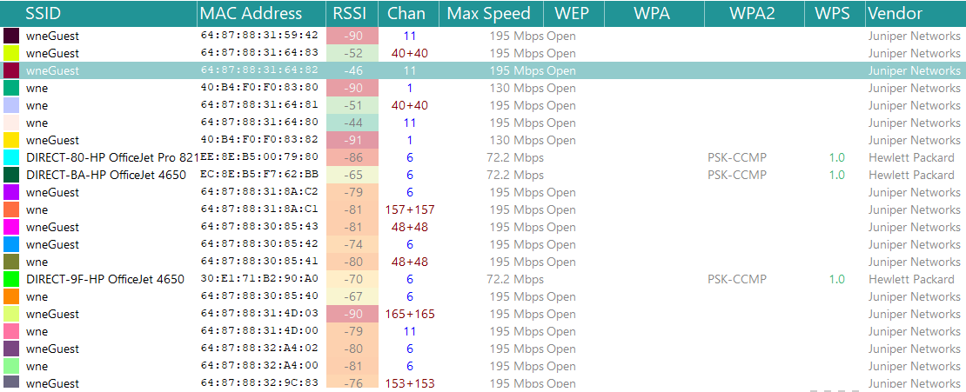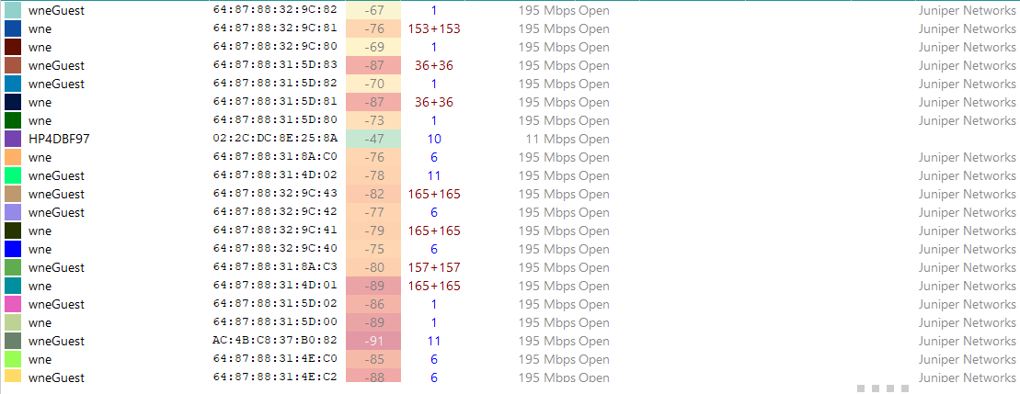

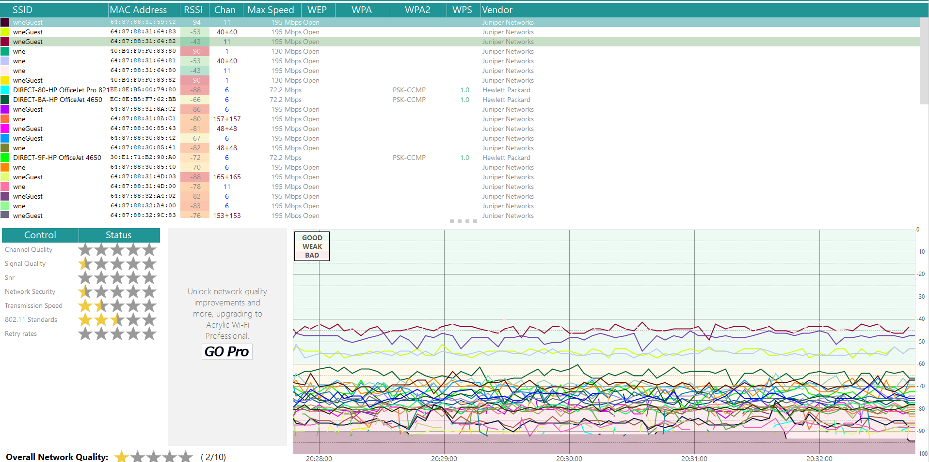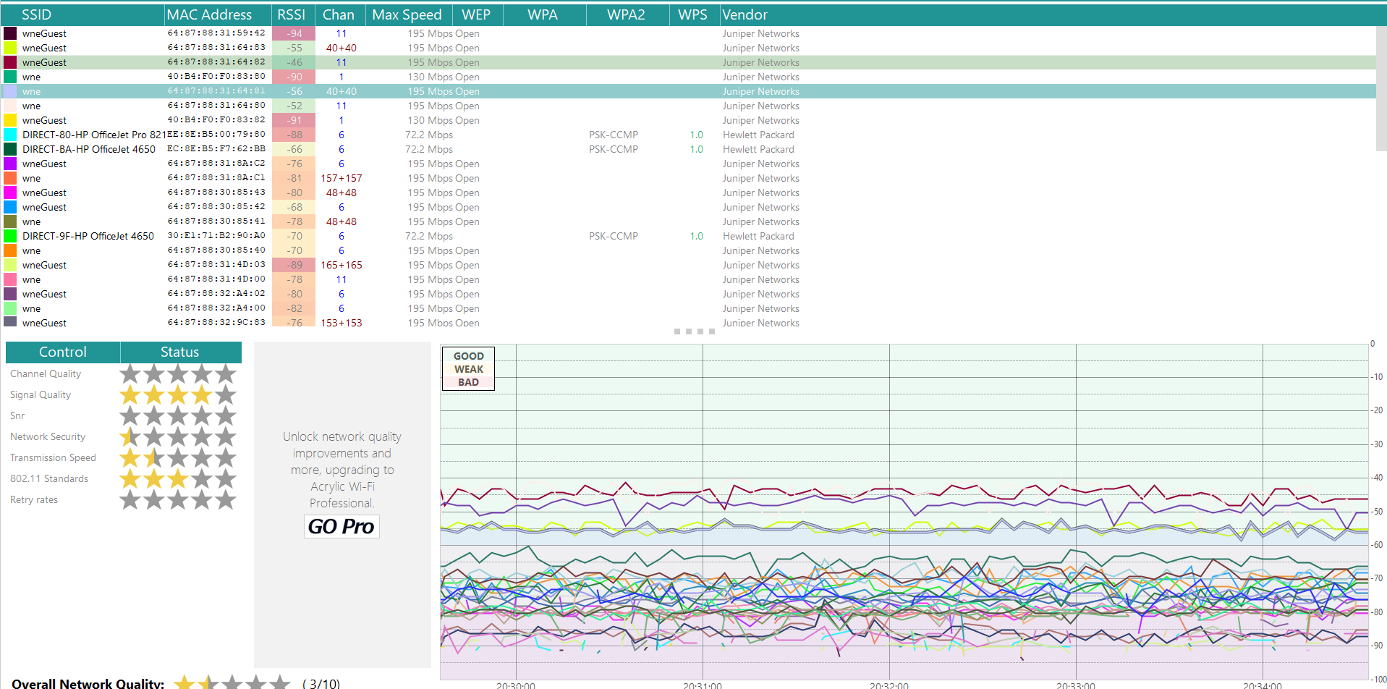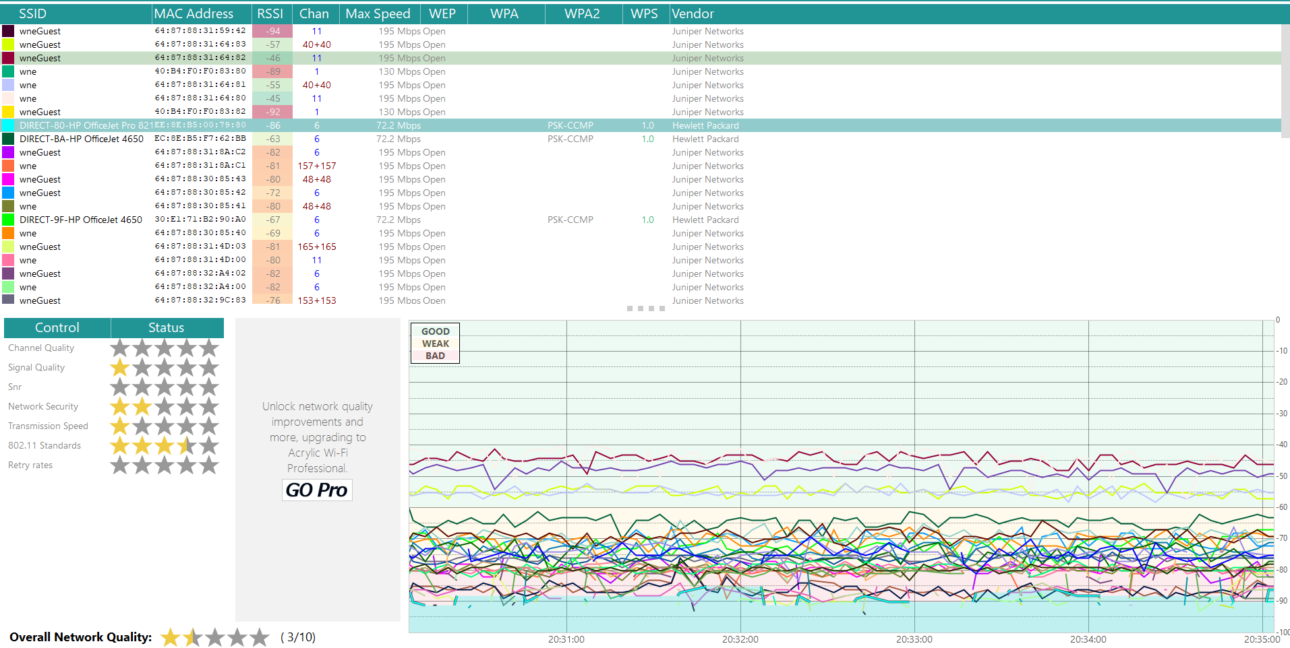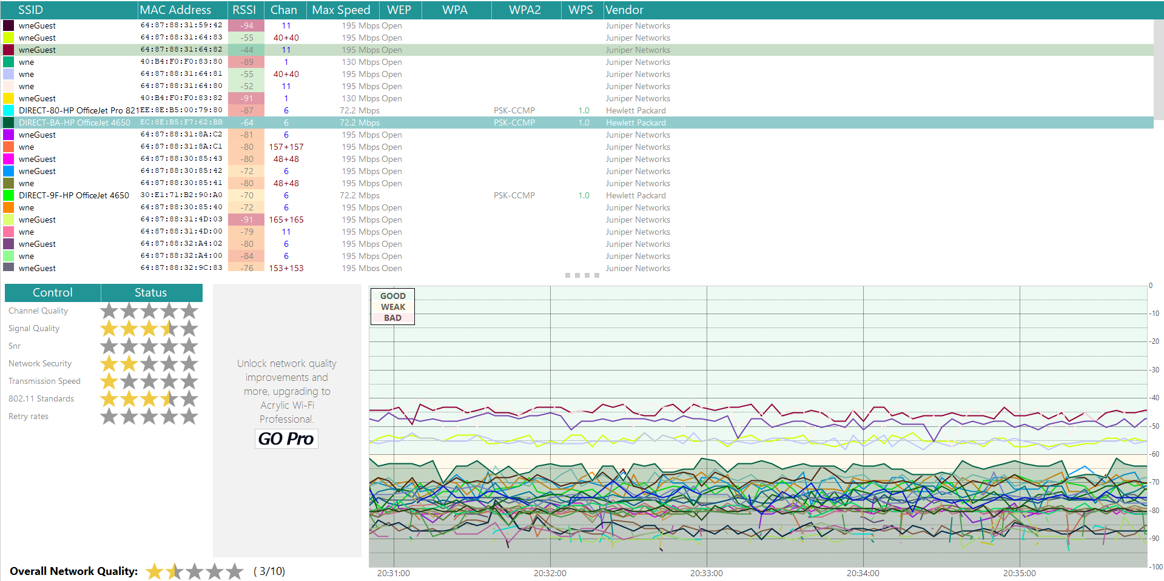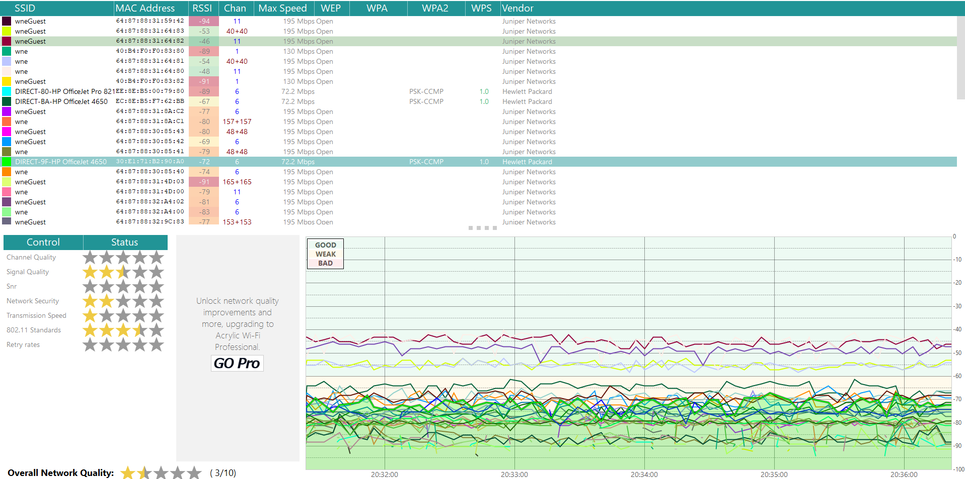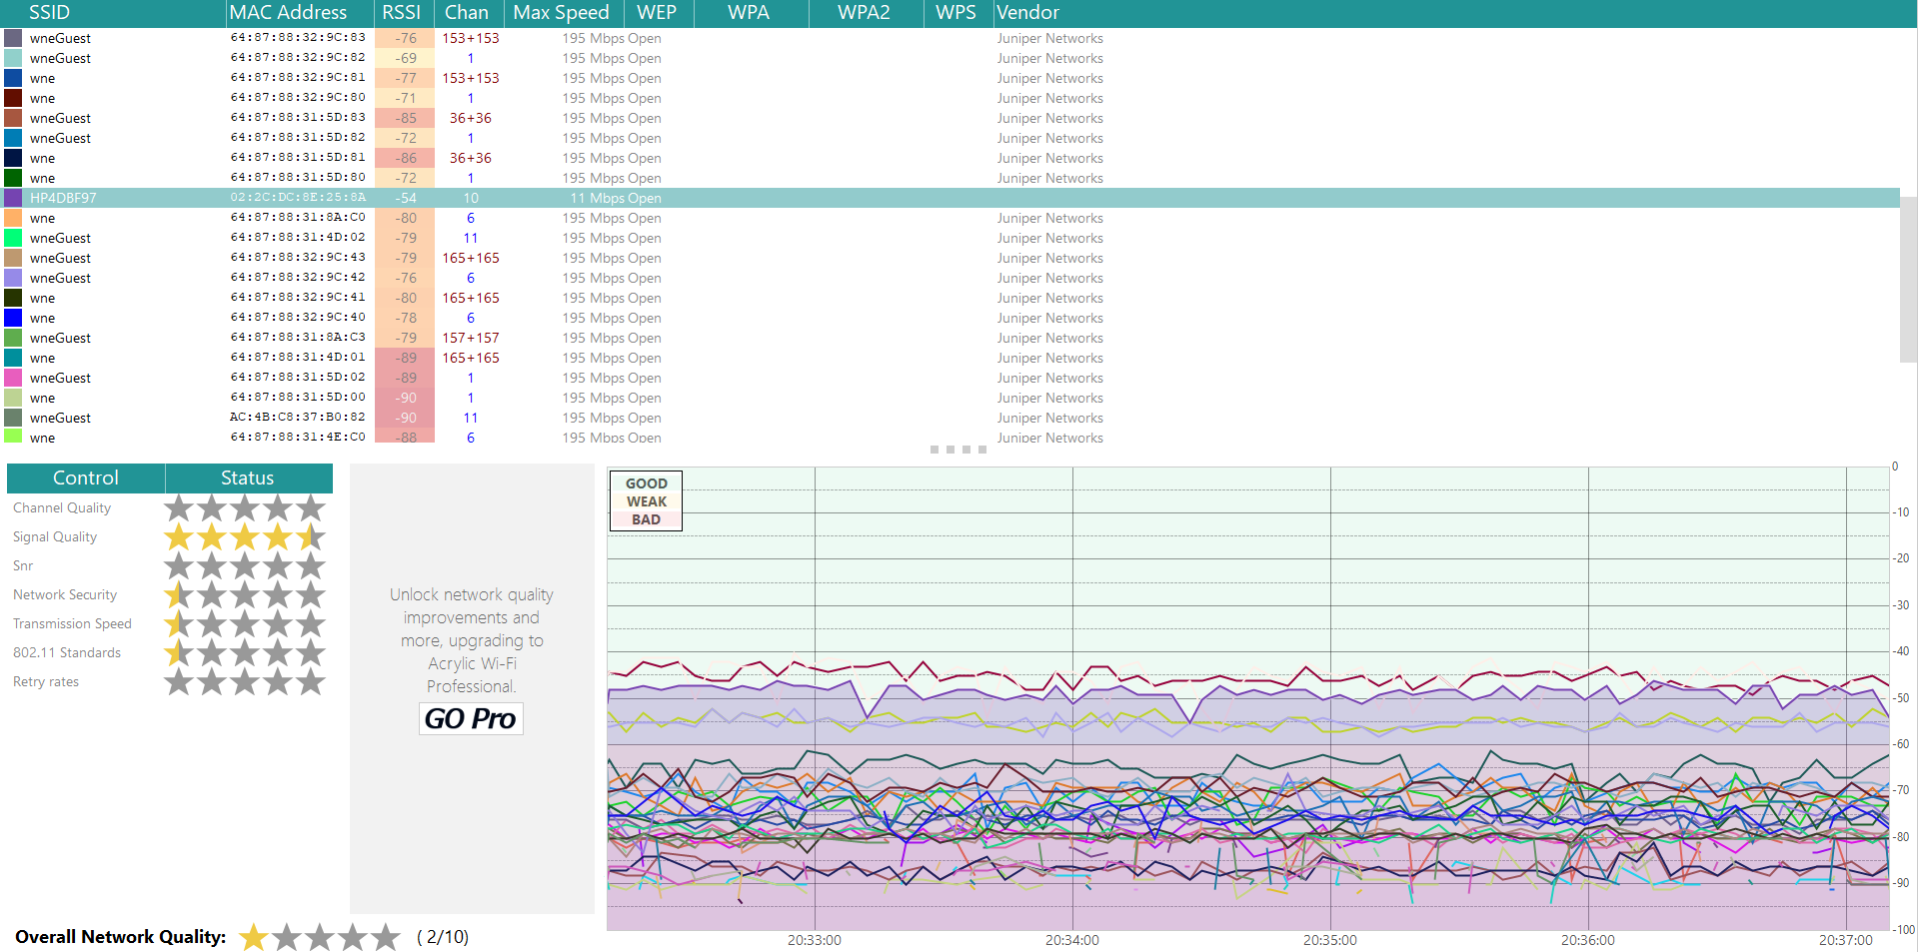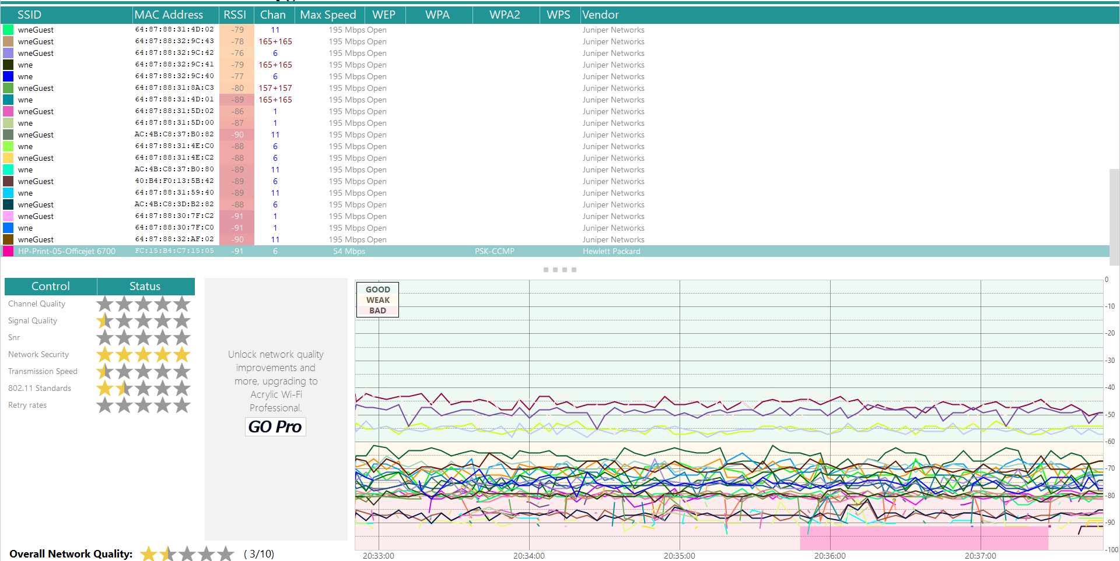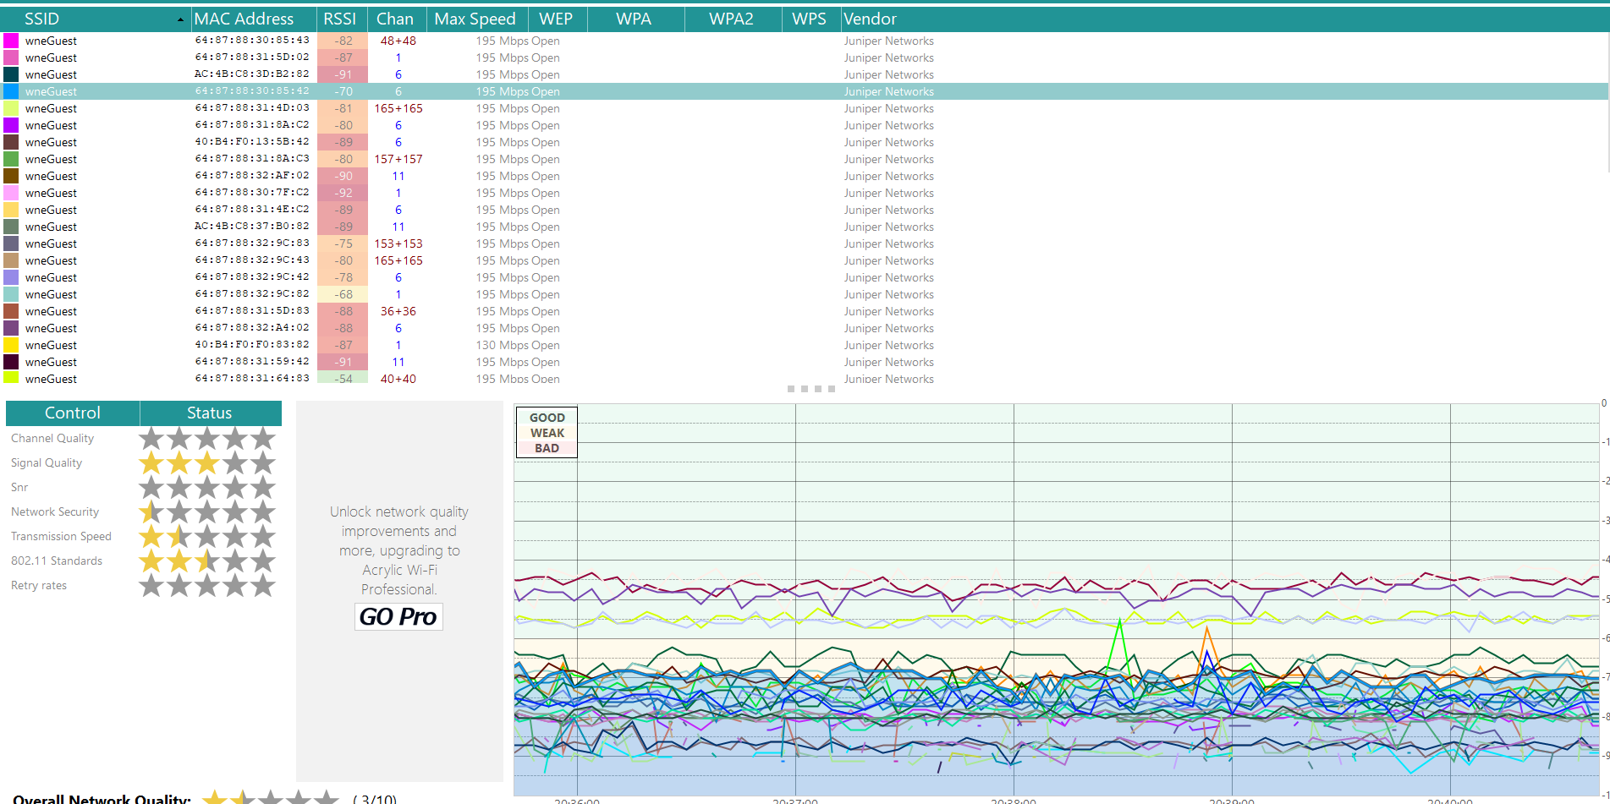

After I started using my cellphone: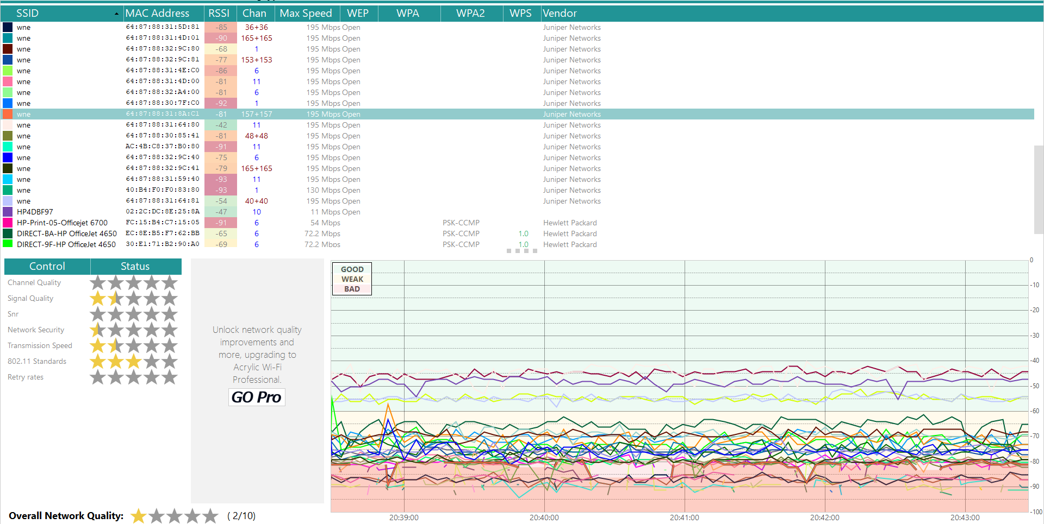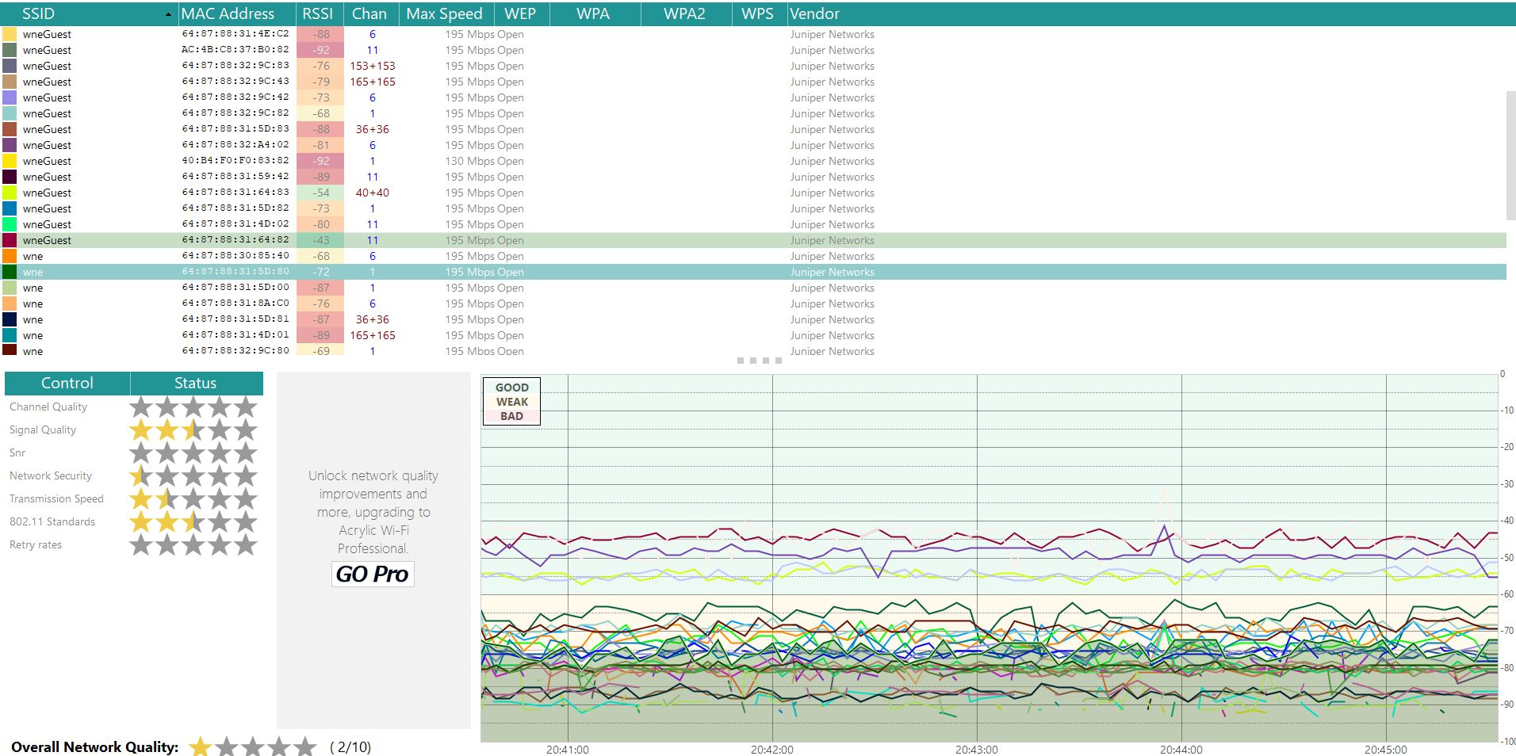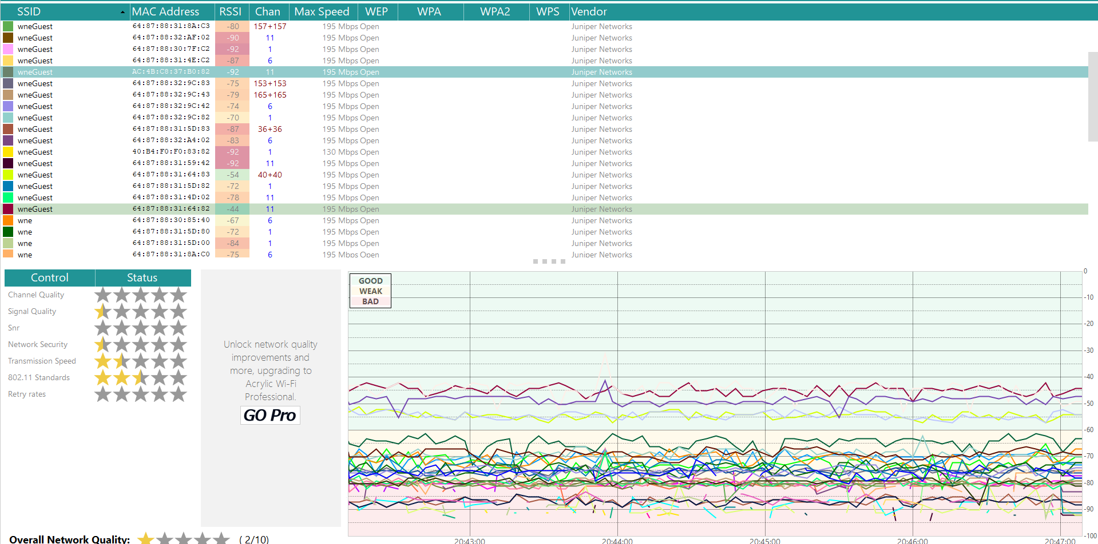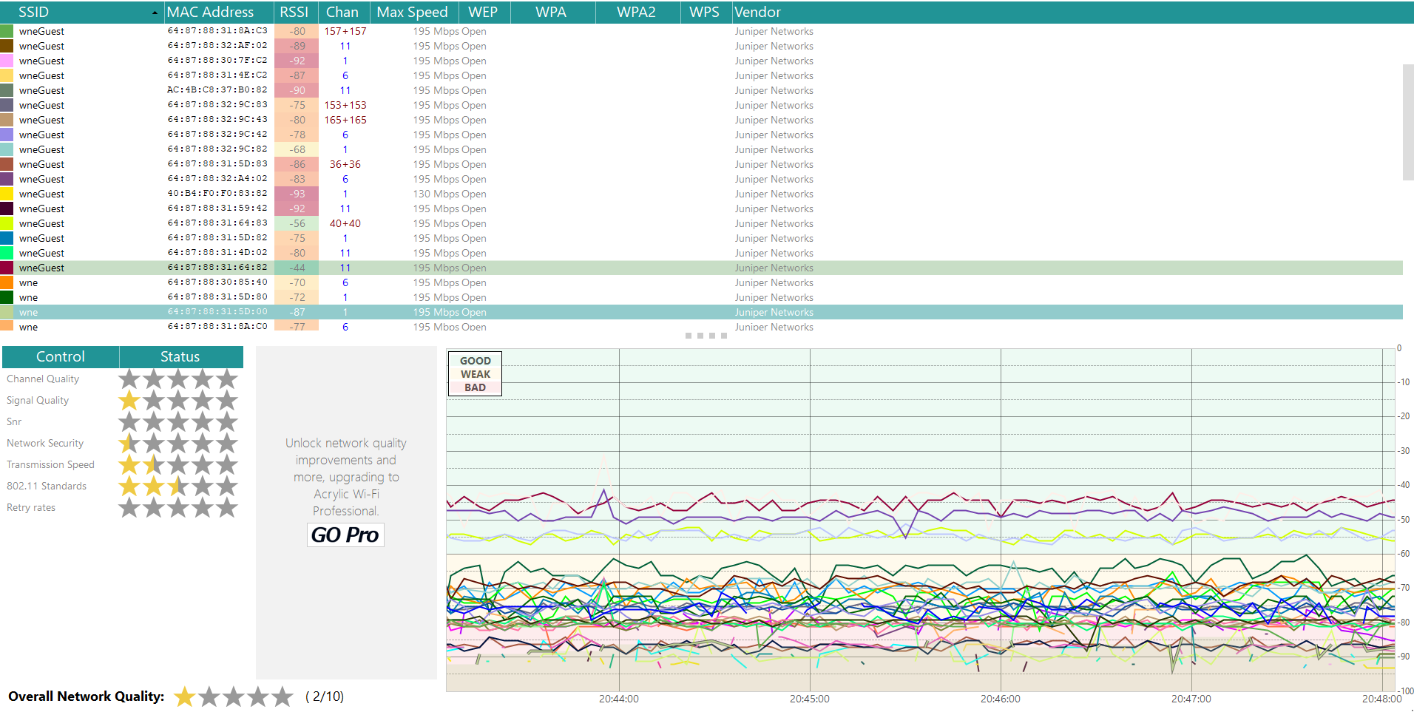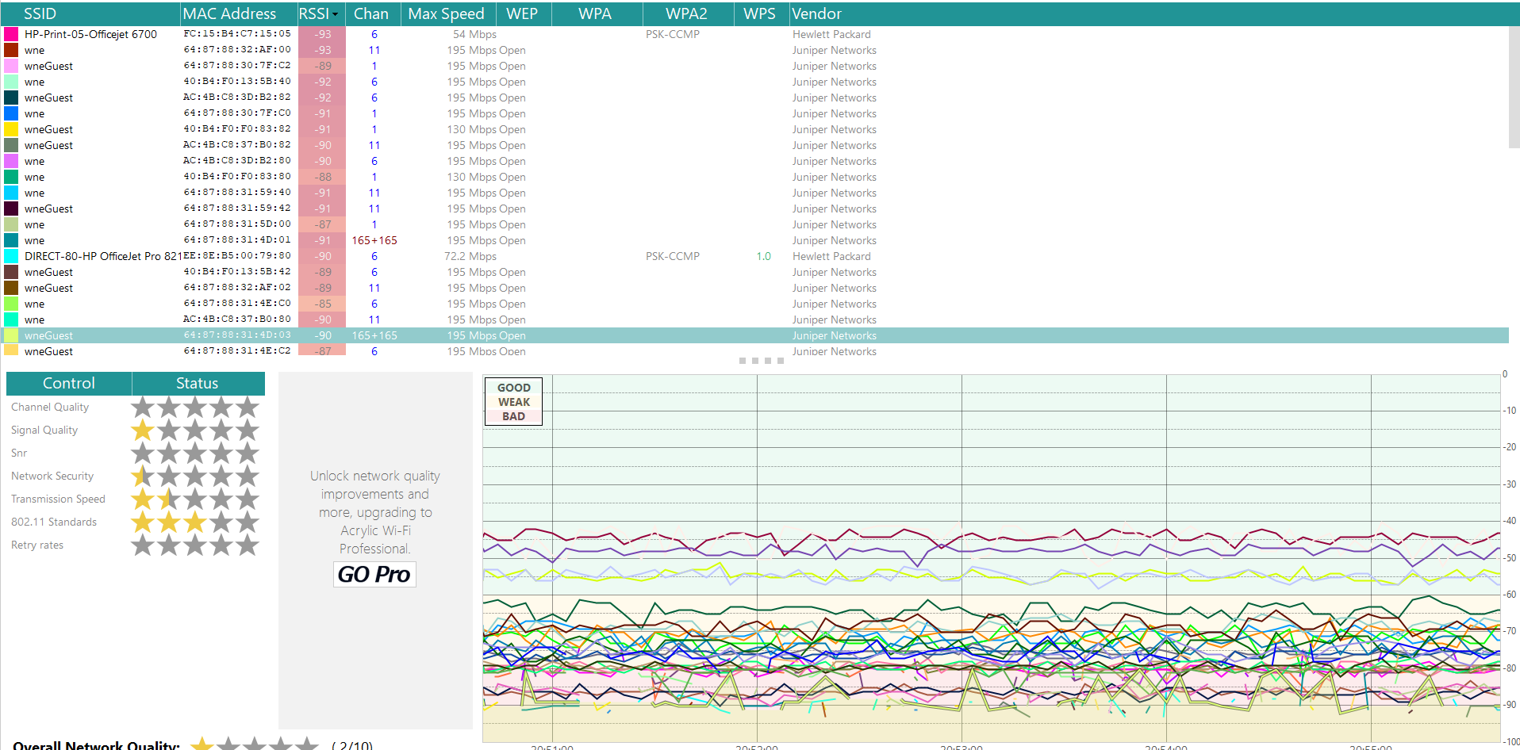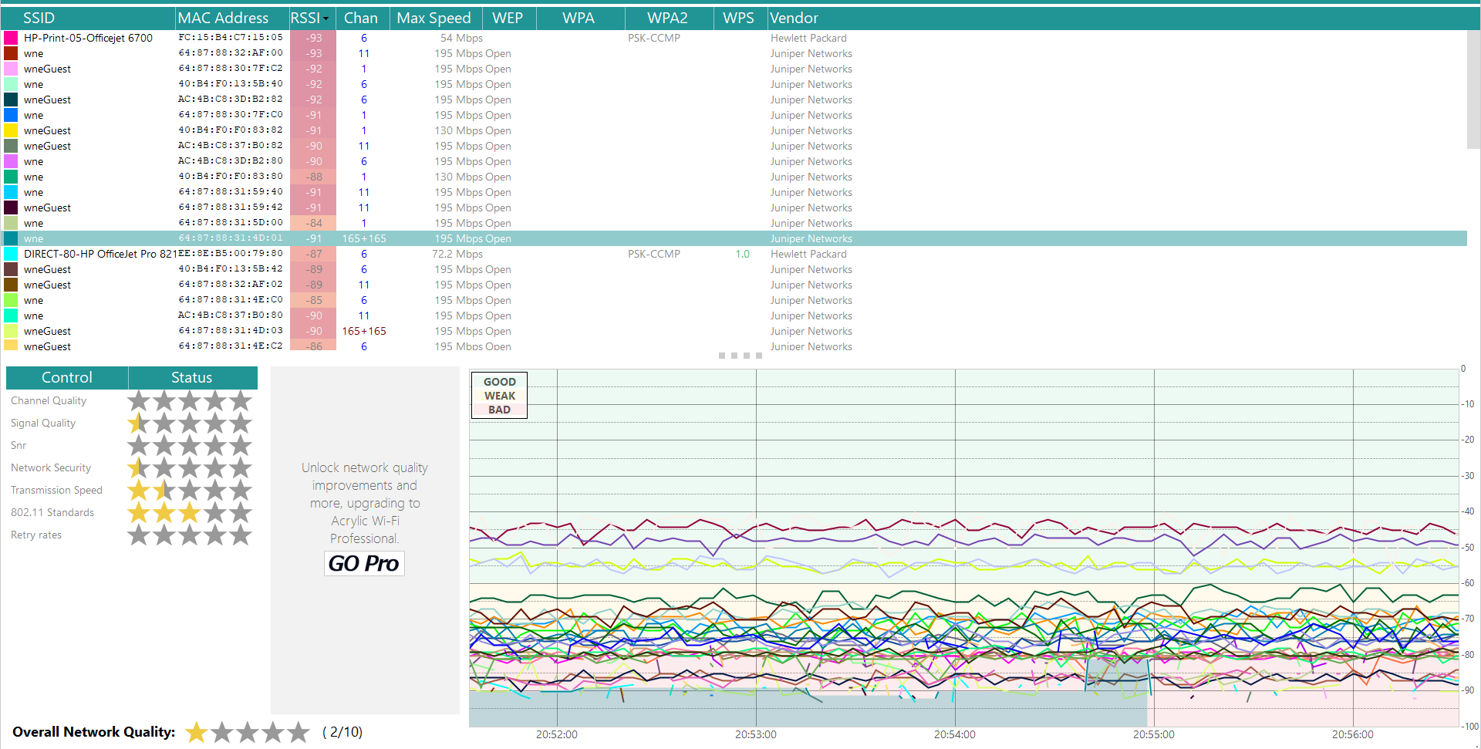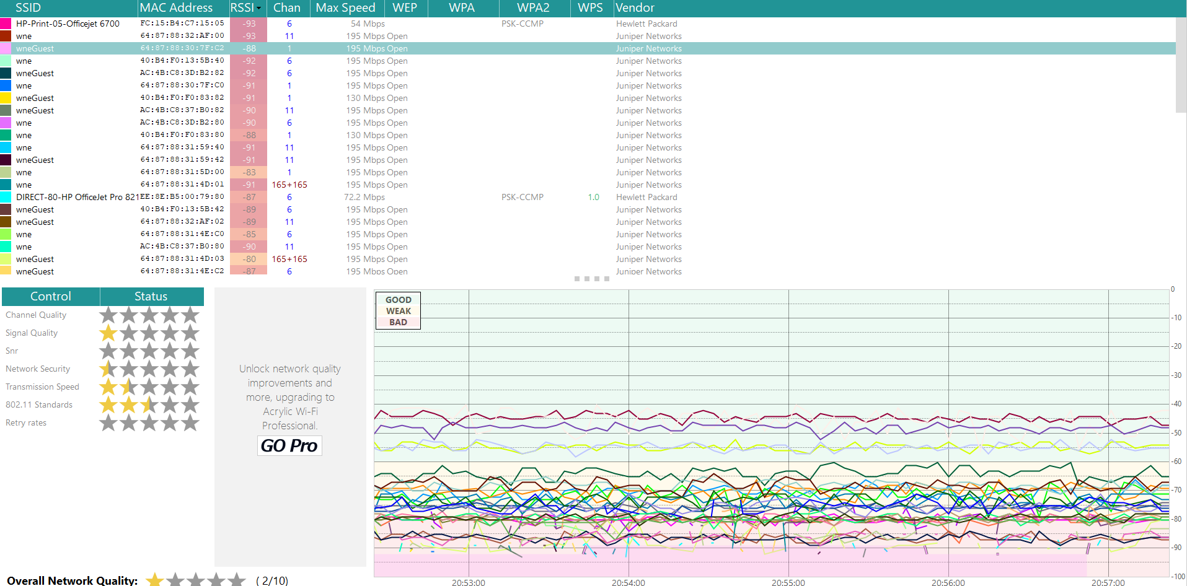

Screenshots of SSID to Vendor area after half an hour: 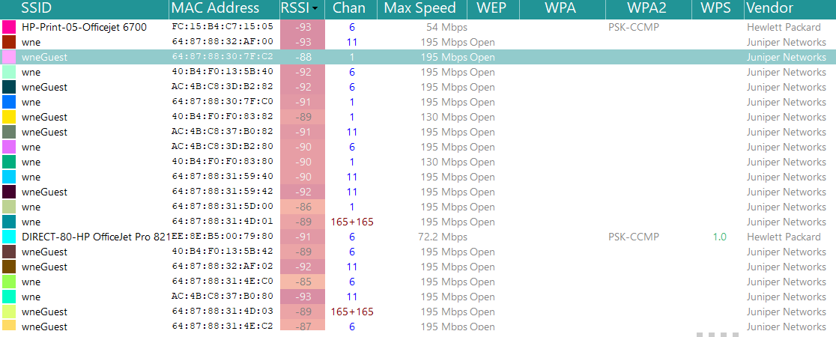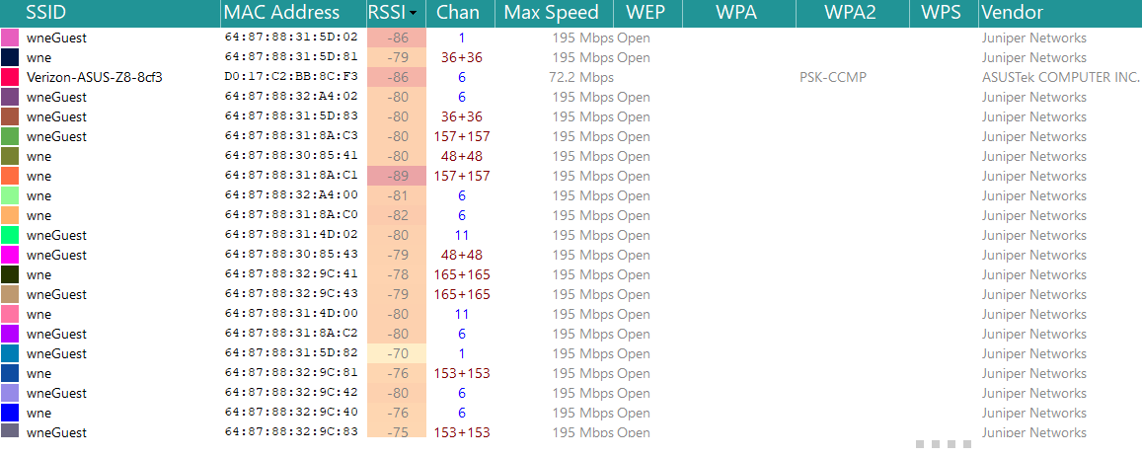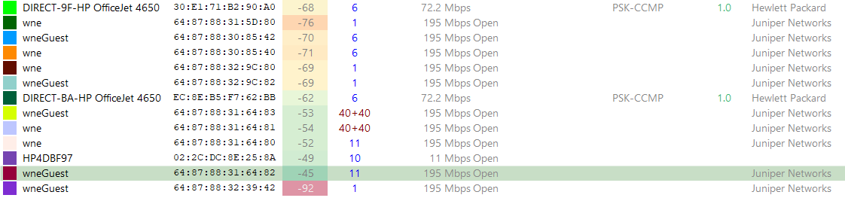

Final Screenshot overall: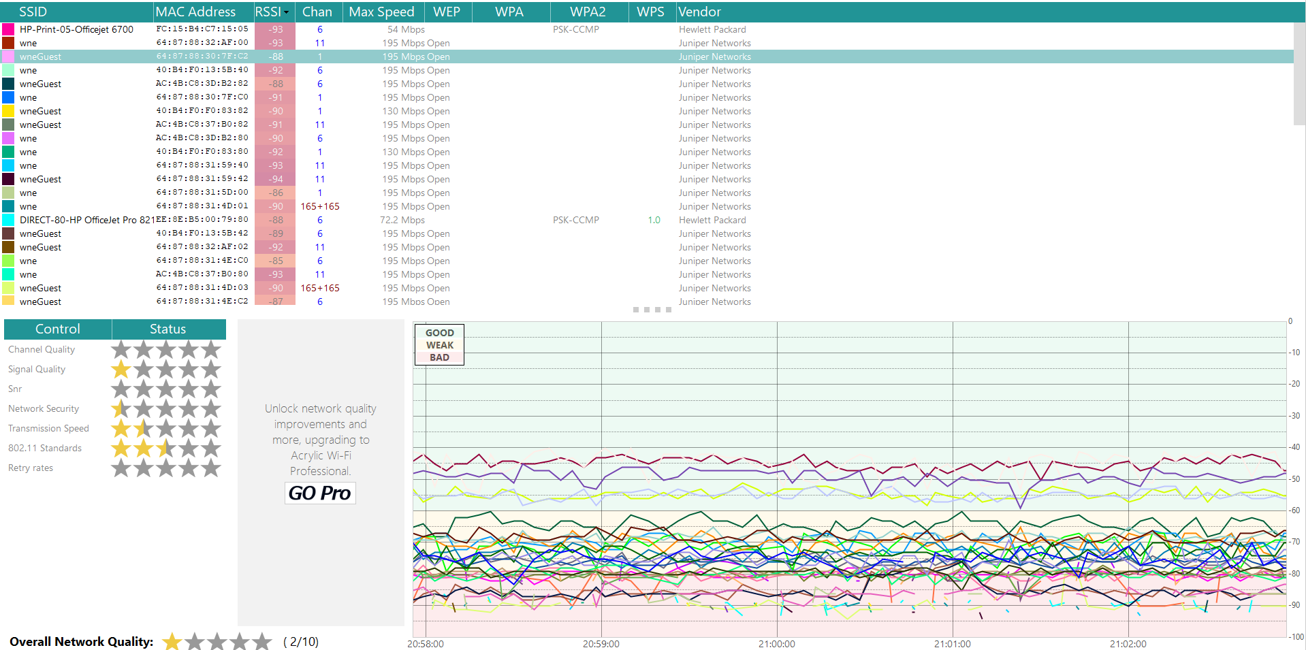

Given the low activity found, I waited about ten minutes to establish a baseline of the connectivity when the classroom was practically empty, then I took out my cellphone and started to open apps such as Facebook, Instagram, Twitter, and Youtube.

I started taking screenshots again, spacing them out in approximately 7 minute intervals, and noticed that connection quality had lowered, and that there were more ‘broken’ pieces of graph lines in the bottom ‘Bad’ connection shaded area as well as some ‘broken’ lines in the top ‘Good’ shaded area. Lines traveling in the ‘Weak’ shaded area seemed to do better than either the Good or Bad areas in that those lines mostly seemed to be intact, although you do have lines that seem to spike drastically between the Weak and Bad area on some of the SSIDs. Note that each colored line on the graph links to an SSID in the SSID to Vendor field table and you can batch them of by looking at the little colored box next to an SSID, like one wne has a box next to it that’s light pink, and another wne SSID is blue.

It is noted that the average Netowrk Quality of all the SSIDs noted is rated 2 out of 10, or 1 star, and the quality across controls such as Channel Quality, Network Security, 802.11 Standards, Aad Retry Rates average out to about 1 and a half stars, slightly closer to two stars in regard to 802.11 standards.

I suspect one of the wneGuest graph lines that spike down into Weak or Bad connectivity areas is the one my cellphone is hooked up to, suggesting a correlation to signal strength in use versus not in use, with the understanding that the Wi-Fi antennas in cellphones aren’t as strong as the ones that come in laptops.

## Suggested Improvements

One of the first things I looked at was whether the listed SSIDs shared the same channels and were next to each other, or in this case, on top of one another, which could account for some of the attenuation discovered.

Of interest, the first, as well as the three screenshots that show all the SSIDs, show that DIRECT-80-HP OfficeJet PRO 821, DIRET-BA-HP-OfficeJet 4650, and wneGuest that were all atop one another all shared channel 6. DIRECT-9F-HP OfficeJet 4650 and another instance of wneGuest also shared channel 6. So did two different instances of wneGuest and wne. Only one set of wneGuest and wne share channel 1, the rest shared channel 6. So, my first suggestion would be better channel management such that no two SSIDs/networks that are net to/on top of one another share the same channel.

From a broader perspective, I would also check to see if the APs are located in areas where interference from electromagnetic-dense areas, like rooms where there is florescent lighting and cordless phones. Also, you might have cases where there are both wired and wireless connections trying to talk to the network through both types of connections. Are the power levels too low or too high or are there any incorrect antenna types being used? Given that I don’t have a layout of the campus network, I cannot say for sure at this time which of these issues are possible, likely, or unlikely.

However, if Aps are located in areas with high EMI, you could consider moving the access point to a nearby location where this isn’t an issue, or at least not as big an issue. If you have a case where there are wired and wireless connections trying to talk to the network at the same time, lock down an area to be either strictly Wi-Fi, or strictly Ethernet, depending on realistic business concerns. Check power levels, and if there are cases of too low or too high power levels, adjust the general area to about 50% power level and make adjustments as needed. If you have a building and want the building covered for Wi-Fi, a unidirectional antenna should be put in place if there is an omnidirectional antenna being used currently.

Since H201 was rather inactive at the time of measurement and given that my home network also shares space with other home networks in an apartment building, I decided to monitor that over a half hour period as well.

## Home Network/Apartment Building

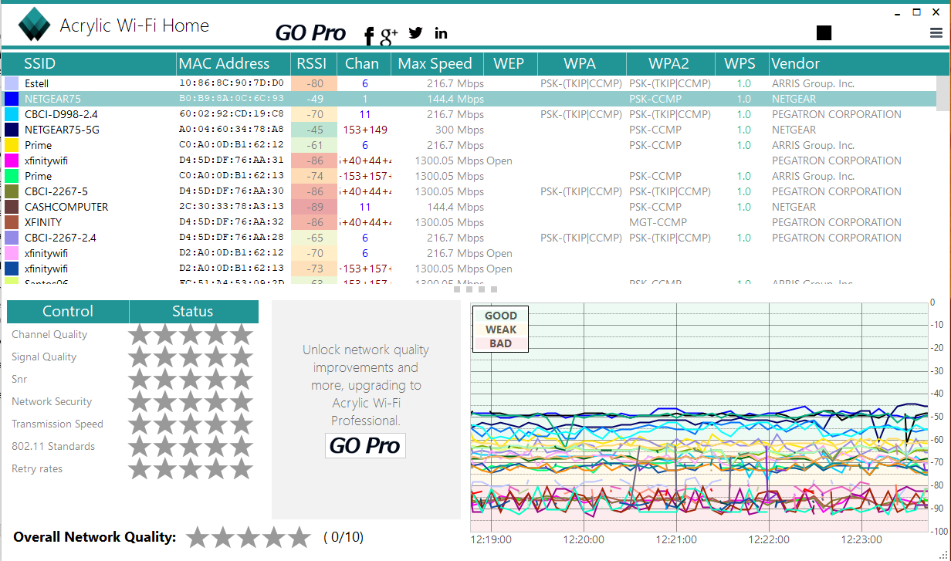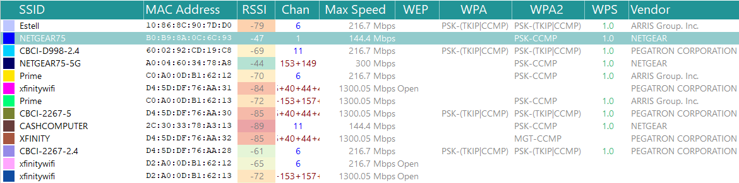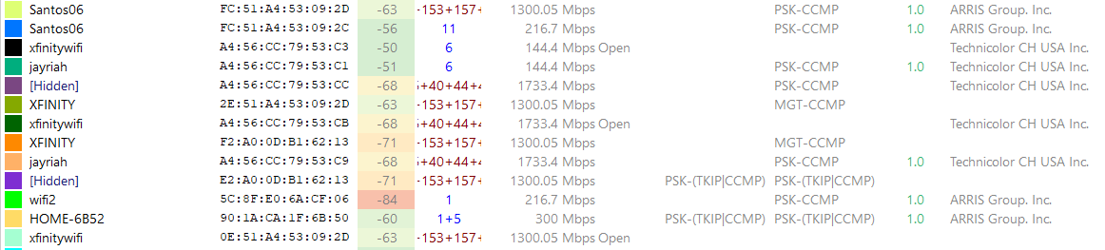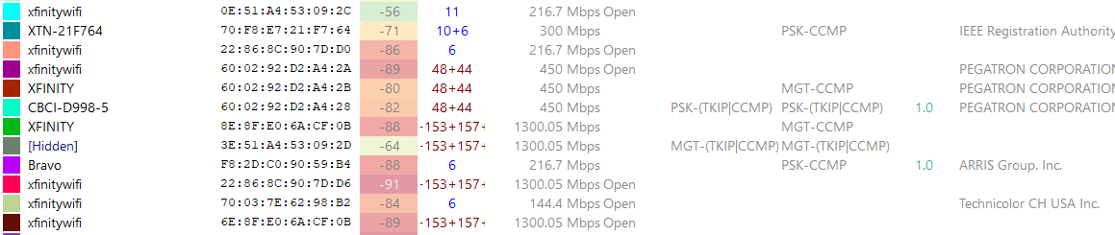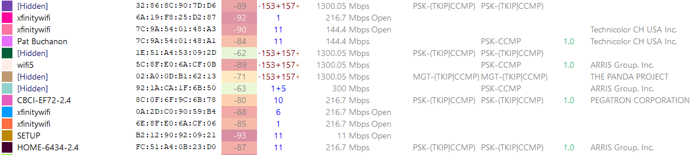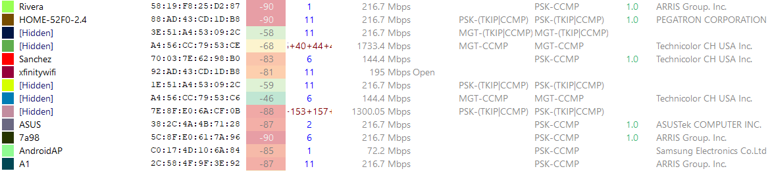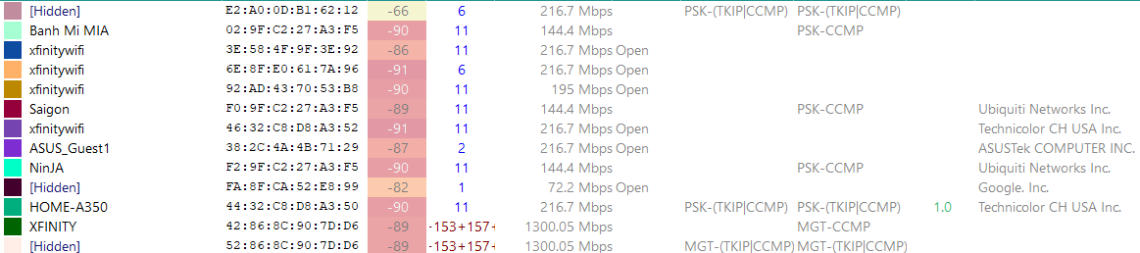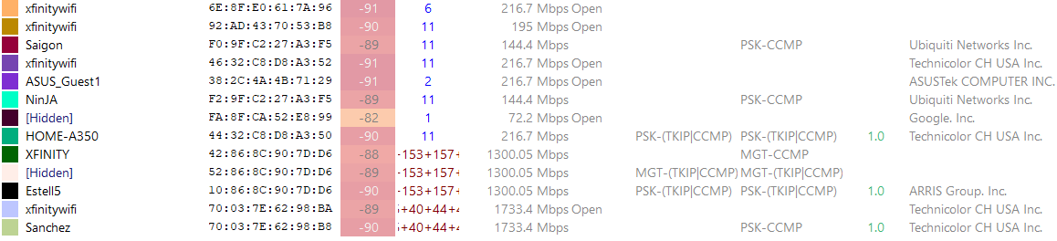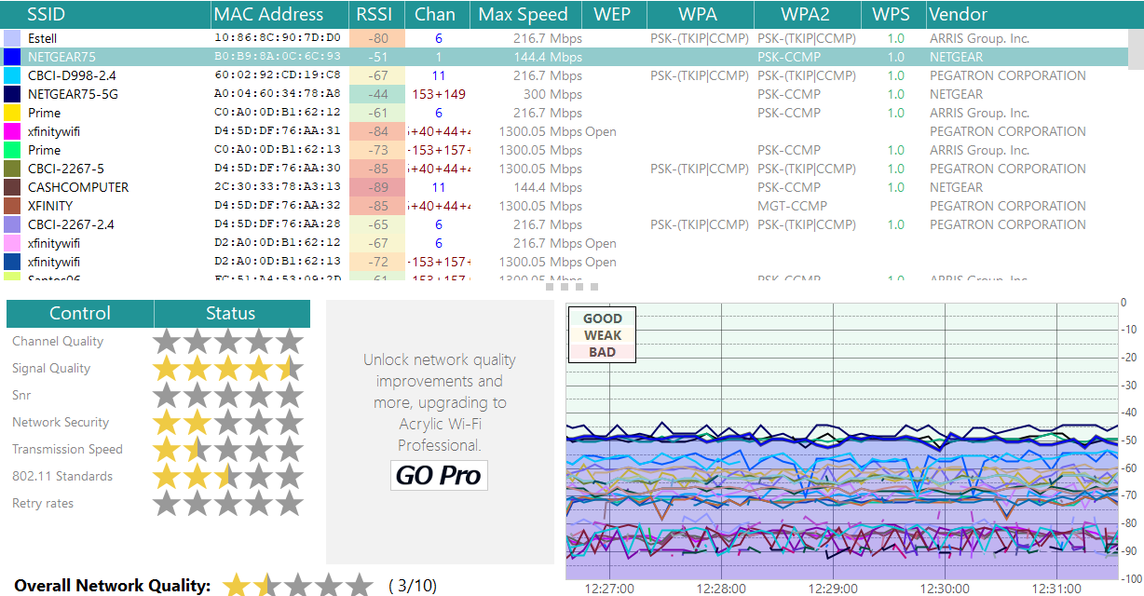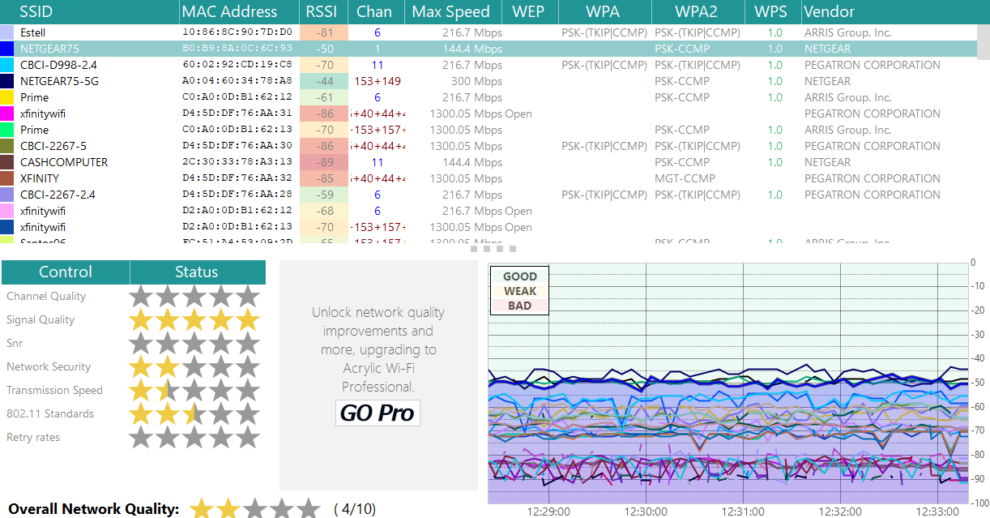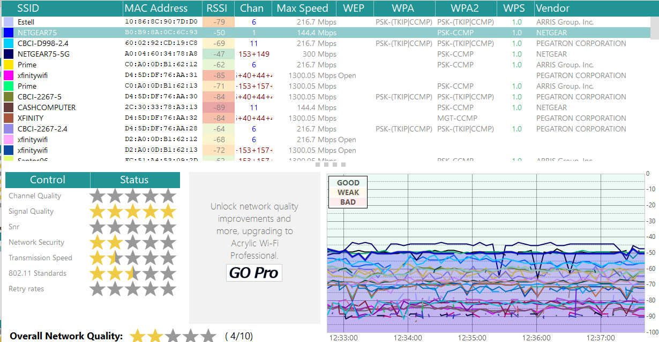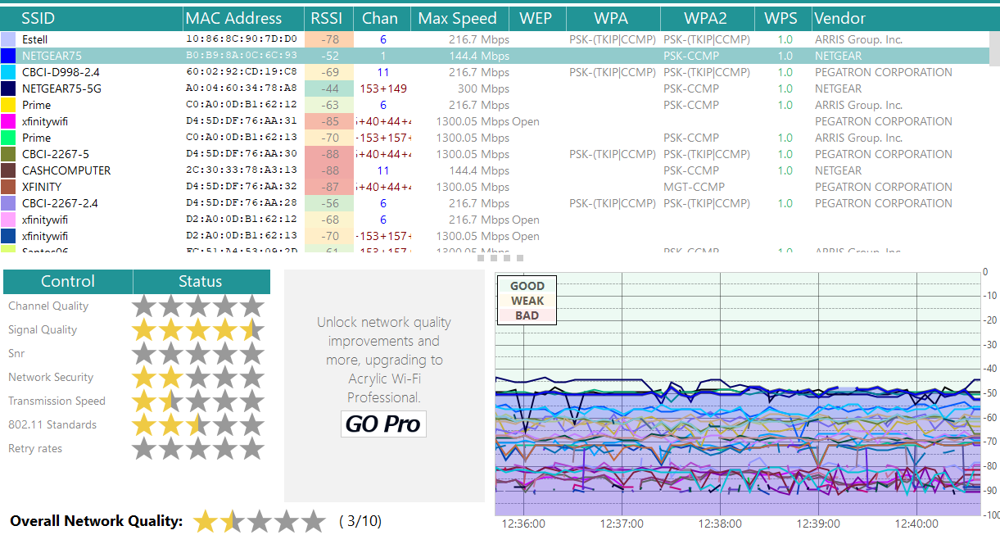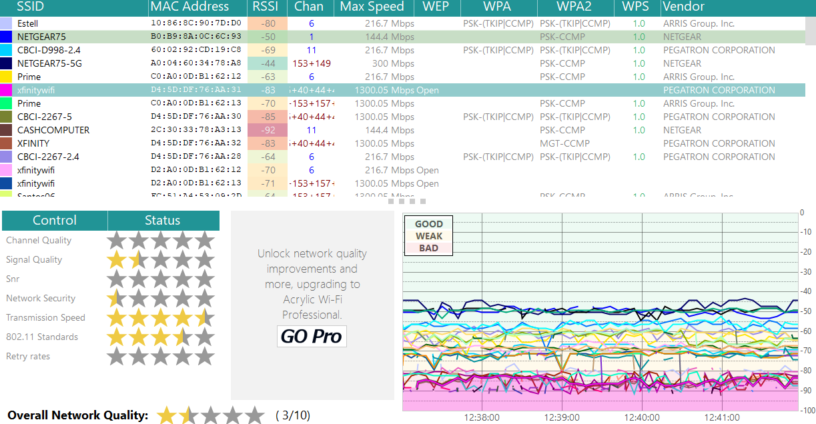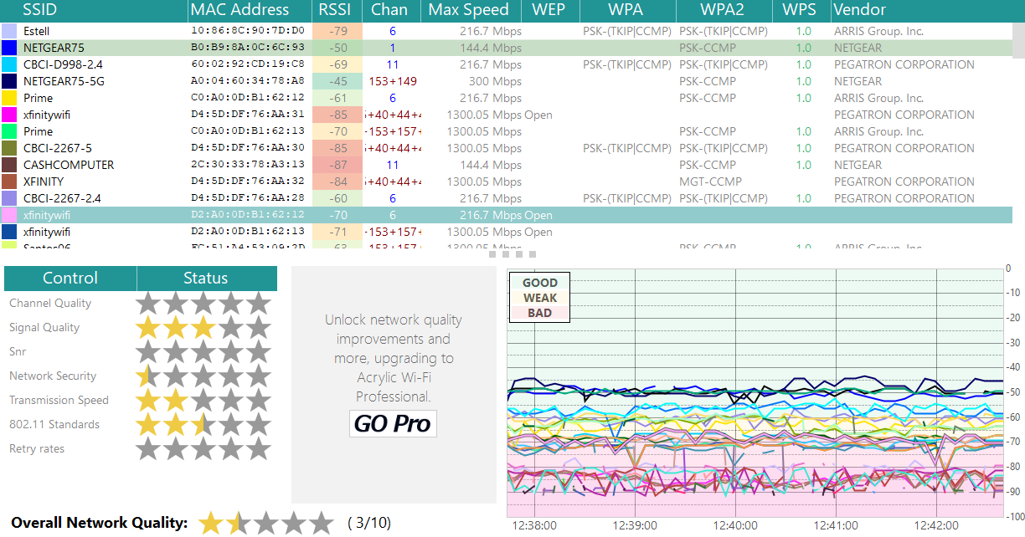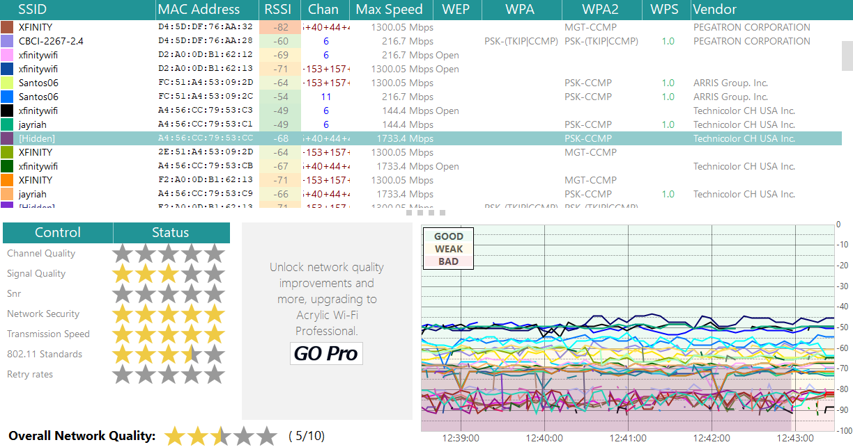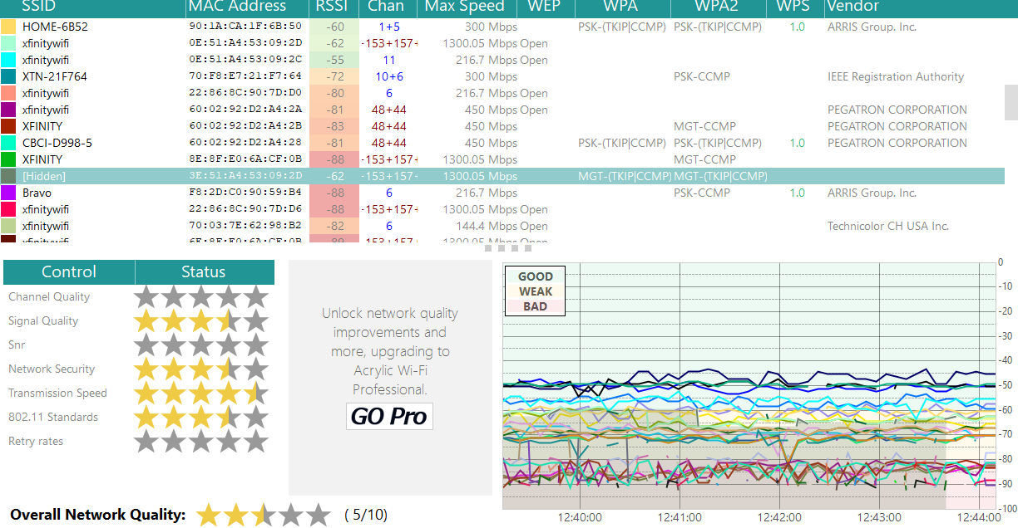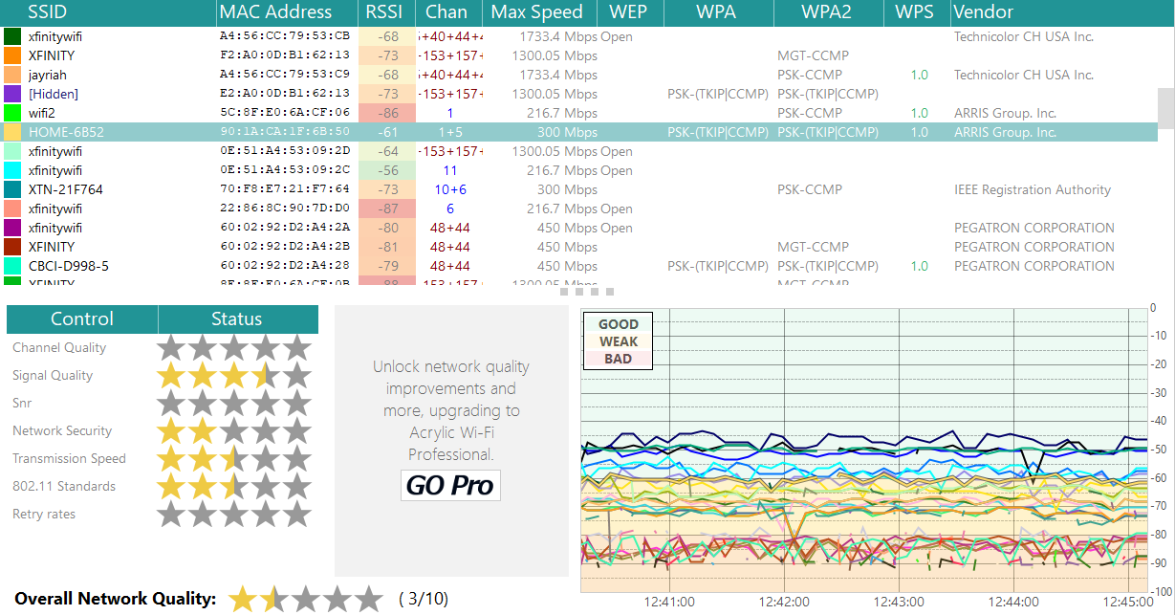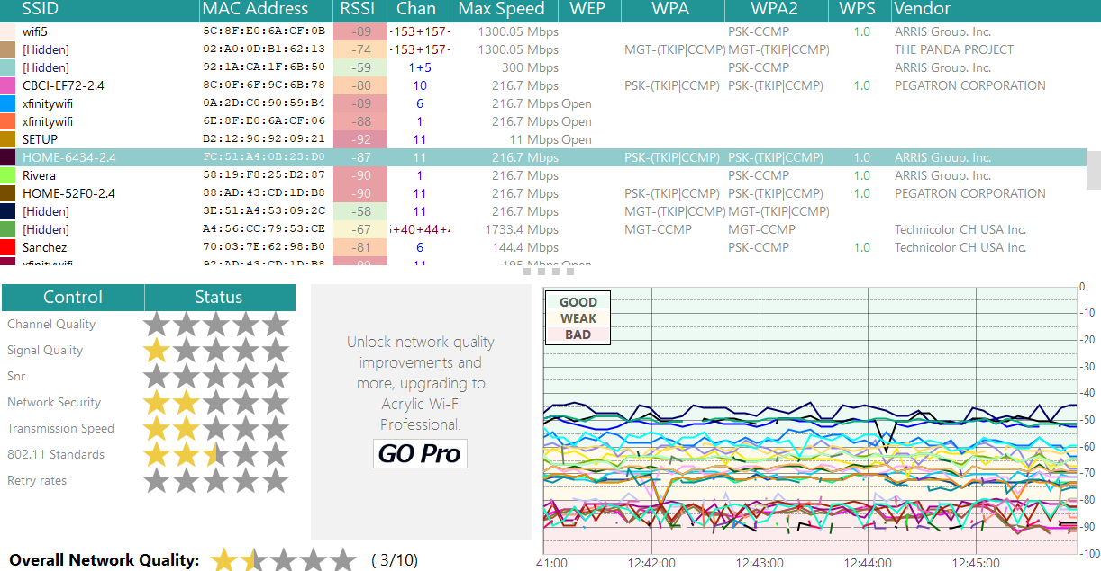

As you can see, I had a surplus of data to study given the number of networks picked up. I suspect I was getting a neighboring business that shares building space with my apartment building but is sectioned off.

Given the rather large amount of SSIDs, I decided to start looking at my own home network, then comparing two SSIDs of the same type. For example, I compared two different SSIDs that shared the same, or similar names, such as the two xfinitywifi SSIDs.

**My home network**: When simply connected and not actively going out on the web on my web browser, downloading freeware or browsing YouTube, my overall Network Quality went from 3 out of 10, or 1 and a half stars, to 4 out of 10, or 2 stars. My Signal Quality went from 4 and a half stars to five stars, Network Security, was maintained at 2 stars (which isn’t all that great, considering). Transmission speed and 802.11 Standards maintained at 1 and a half and 2 and a half stars respectively. This was whether or not I was doing nothing on the network through when I was actively on the network (downloading, browsing, YouTube, etc.)

When I was actively using my network, my Overall Network Quality went back down to 3 out of 10, or 1 and a half stars and my Signal Quality dropped back down to 4 and a half stars. However, the dark blue line graph that represented my network remained consistently within the Good to Weak range and only occasionally spiked into the Bad range.

**Xfinitywifi**: The next two networks I compared was xfinitywifi. For the first SSID, color square/graph line legend deep pink, the Overall Network Quality maintained at 3 out of 10, or 1 and a half stars. Signal quality improved from 1 and a half stars to 3 stars over a 1 minute period. Network Security maintained at half a star. Both Transmission Speed and 802.11 Standards maintained. Transmission Speed, 4 and a half stars; 802.11 Standards, 3 and a half stars, all within a 2 minute period.

Of note, even though the first xfinitywifi has higher ratings than the second one, the deep pink/magenta graph line and the pale pink graph line representing the network was consistently in the Bad shaded area of the graph, with occasional dips up into the Weak shaded area. Perhaps that’s one of the reasons why it was also rated at 1 and a half stars for Overall Network Quality.

The second SSID, color square/graph line legend pale pink, the Overall Network Quality was 3 out of 10, or 1 and a half stars. Given that the Network Security was at half a star, Transmission Speed and 2 stars, and 802.11 Standards were at 2 and a half stars, while the Signal Quality was only three stars, it’s not surprising to see the reason for that 1 and a half star Overall Network Quality Rating. The other SSID I’d consider dropping to 1 star since it’s Signal Quality was only rated at 1 and a half stars, all within a two minute period. It’s pale pink graph line represented in the graph was also consistently in the Weak shaded area, with some spiking down into the Bad shaded area, which is actually better than the first SSID.

**[Hidden]**: I picked two hidden networks, mostly to see if there’d be any telling differences; there were. The first hidden network, colored square/graph line legend dark purple/marron had an Overall Network Quality of 5 out of 10, or 2 and a half stars. Signal Quality was 3 stars. Network Security and Transmission Speed were both at 5 stars, which is a huge difference over the other home networks. 802.11 was 3 and a half stars, all over a two minute time period.

Also, the graph line representing this network shifted between the Weak and Bad areas of the graph, which surprised me given the ratings listed above.

The second hidden SSID, color square/graph line legend olive green had an Overall Network Quality of 5 out of 10, or 2 and a half stars. Signal Quality was 3 and a half stars, a little better than the first hidden network. Network Security rated at a lower 3 and a half stars. Transmission Speed was also lower at 4 and a half stars, and 802.11 Standards were the same as the other hidden network at 3 and a half stars.

The graph line representing this network stayed consistently within the Weak shaded area of the graph, which might account for why it didn’t get a lower Overall Network Quality rating.

**HOME**: Finally, I chose two different home networks to compare.

HOME-6852 color square/graph line legend goldenrod; Overall Network Quality, 3 out of 10, or 1 and a half stars. Signal quality, surprisingly a little better than either of the hidden networks above, rated at 3 and a half stars. Network Security, 2 stars; Transmission Speed, 2 and a half stars; 802.11 Standards, 2 and a half stars.

The graph line representing this network stayed right between the Good and Weak shaded area of the graph, which is also surprisingly better than the hidden networks above.

HOME-6434-24 color square/graph line legend dark brown; Overall Network Quality. 1 and a half stars, or 3 out of 10. Network Security, same as the other HOME, 2 stars; also the same 802.11 Standards rating at 2 and a half stars. However, the Transmission speed is a little lower, at 2 stars vs. 2 and a half.

The graph line representing this network stayed consistently in the Good shaded area of the graph, with occasional dips into the Weak area. This also out performs the hidden networks above, yet they had clearly better Network Security, Transmission Speed, and 802.11 Standards. Interesting.

## Suggested Improvements

Once again, I first checked for channel overlapping, where two different listed networks shared the same channel.

The first set of two networks grouped together that I spotted were the CBCI-2267-5 and an instance of xfinitywifi, are both on channel 6. While not the majority of shared channels in this case, it does show up as the channel for both Santos06 and another instance of xfinitywifi; what is it about channel 6?. The other two cases of channel sharing are between three networks; two different instances of xfinitywifi and one instance of CBCI-0998-55, which all share channel 48 + 44. Of note, the next channel-sharing set appear right below it for XFINITY and [Hidden]; both share the channel 153 + 157. Again, as a first step, implement better channel management such that no two SSIDs/networks that are net to/on top of one another share the same channel.

However, to be fair in regard to above, this is not a scenario in which one corporate or educational entity owns the overall network of the building/surround area. Rather, the Wi-Fi Analyzer is picking up multiple different home/small business networks, with varying ISPs (though Xfinity/Comcast does seem to be the most common), so that sort of mainstreamed network management and infrastructure is unrealistic given the reality of this situation.

Also, because each apartment/small business is it’s own LAN, trying to ascertain rooms where there is florescent lighting, cordless phones, and other items that cause EMI, is outside of the scope of a single network administrator; infrastructure adjustments as well as not having the building be under one ISP umbrella make the implementation of this solution unrealistic.

The same goes for the case of wired and wireless connections trying to talk to the network through both types of connections. Most home networks are equipped for hardwire (PC) and Wi-Fi (Laptop, cellphone, tablet) internet; single or family customers aren’t likely to switch strictly to either Wi-Fi or Ethernet networks.

Are there any incorrect antenna types being used? In this case, probably not. For an apartment building where Satellite TV, along with cable TV situated per customer preference, you are likely to have both omnidirectional and unidirectional antennas are situated on or inside the building.

While checking power levels to see if there are cases of too low or too high power levels is still a valid problem-solving step, this would need to be mediated through the landlord as well as any maintenance personal they have on hand. Realistically, an older apartment building is likely to have areas where there is either too much power or too little of it and given the cost of reconstruction, it is unlikely the owner of the building or the landlord would agree to this step. Even if they did, the people renting it may have to move out in the likely event that some of the cost will be passed onto them as an increase in rent.

This is likely something a small to medium sized business must also consider before moving forward with such an adjustment, or if they only have an omnidirectional antenna vs. a unidirectional, etc. Most businesses of this size rent the building they have space in so they may have no say, or would only have a say in it if they offered to pay the cost out of pocket.

# Part II: Diagrams

### Diagram 1: MDF

Here is a screenshot of the finished product: 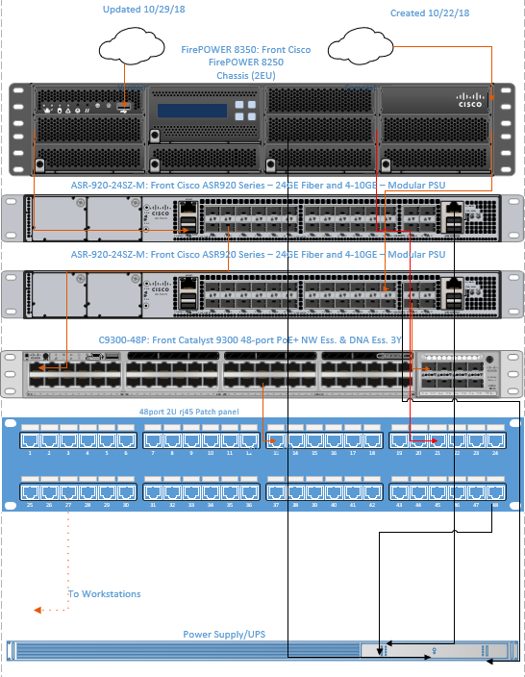

Lines that are red denote internet connections, black lines are power lines. As this is the first time I’ve worked with Visio, I’m aware this isn’t the best looking diagram, but the logistics should still apply such that two ISPs are read into the firewall, which then connect to the routers and switch.

### Diagram 2: Warehouse

Update to reflect shift in walls and at top made sure it said that APs are 2.4 GHz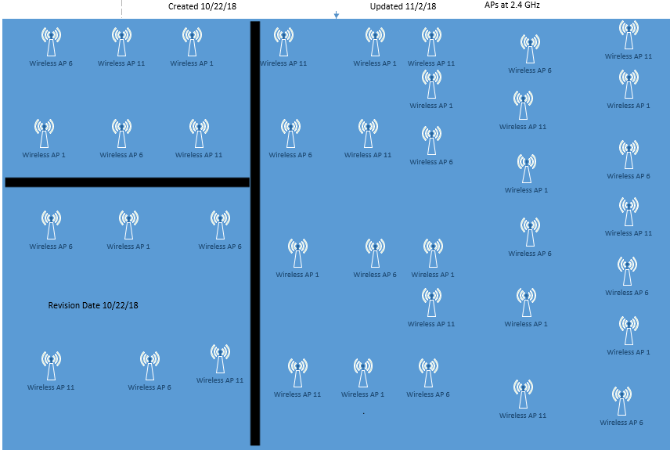

### Diagram 3: Workstations

